# 4. Antagonistic Elements

## Antagonistic Definitions

**1**. Generic name: Racing cars

Game name: Bots

As we mentioned before there will be other cars that will race each other. Clearly, cars will interrupt each other while one wants to pass another. When a player`s car crashes with another car, player will lose the game.

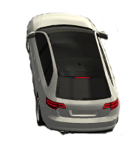 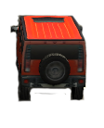

**2**. Generic name: Mr. Ahmadov

Game name: Freezer

When a player hits freezer, the character forces a car to decrease 5 seconds from the timer.



**3.** Generic name: Stone

Game name: “Bereket”

During the game stones start to fall from the sky and if a car touches the stone, player`s score

will decrease.

## 

## Antagonistic Properties

In common sense, antagonistic elements affect the game time and lead a player to lose a game.

## Antagonistic List

1. Bots

2. Freezer

3. “Bereket”

## Artificial Intelligence (AI)

<This is where visuals and written description(s) of the antagonistic element’s behaviors. These should be labeled in such a way that they can be used in level design without having to describe them again. Devise generic names for repetitive behaviors. This is how an AI action could be deconstructed:

* Normal State: What is the object doing if it has not come in contact with the player?
* Detection State: What does it take for this object to detect the player?
* Reaction State: What does the object do as an action after passing the reaction state?
* End State: What happens to the object after player has reacted correctly or incorrectly to object?

If a player reacted correctly, after passing the object scene the object will disappear.

# 5. Global Game Elements

## The Story

Game will take place inside of the ADA University. Boundaries are used for making the game more attractive and challenging. As we have boundaries, when player wants to avoid from obstacles, or wants to hit the characters, a car goes forward, moves to the left and right during racing. Buildings, trees are described as neutral objects in the game. Camera will display the view of 3D game world, and we used third-person camera view for creating more realistic approach to the game. So, camera stays on the back side of the characters in a third-person camera view, and player sees around easily.

## The Story Copy

The story takes place in ADA University. Player chooses its character and start to race with other cars. Moreover, there are also boosts that will be displayed with instructors of ADA University, and their boosts relate to their courses respectively. Antagonistic elements were used for increasing the hardness level of the game.

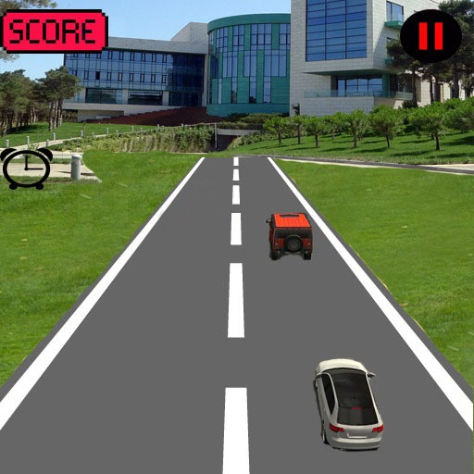

## Concept Art

Before starting to design the game concept, we took some pictures of the university buildings, roads, and added scenes to the real pictures.

 

## Level Design

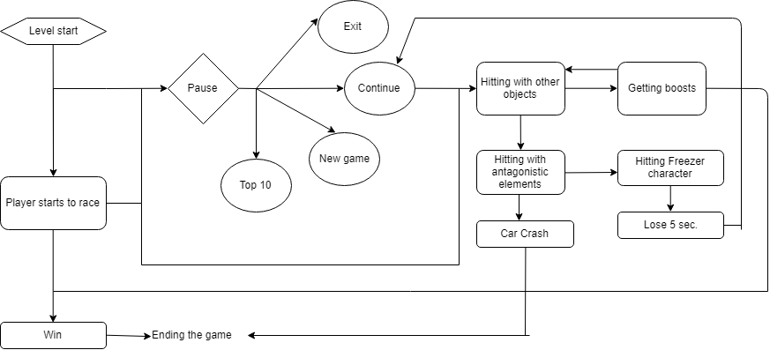

## Level Copy

Here are the characters that were placed in the game. As it is mentioned above, characters have different boosts, and when the car hits one of the characters, it will gain its boost.

  

 

## Audio & Sound F/X

1. Generic name: Background music

Description: plays during the game.

2. Generic name: Selection music

Description: plays during the selection of the levels or characters

3. Generic name: Hitting characters

Description: plays when a car hits character or antagonistic elements

4. Generic name: Finish

Description: plays when the car finish racing

5. Generic name: Crush

Description: plays when a car crush with other cars

6. Generic name: Starting

Description: plays when a game starts, and player presses forward button